(Approx. 741 words)

Creating Poster Art from Photos
By Dick Maybach, Brookdale Computer User Group
August 2020 issue, BUG Bytes
www.bcug.com
n2nd (at) att.net

Creating attractive posters can be a challenge for those of us with limited artistic talent, and while using clipart is quick, often the result is poor. An alternative is, to begin with, a photo and use image-processing software to convert it to a graphic. In this article, I’ll use GNU Image Manipulation Program (GIMP), https://www.gimp.org/, but most similar programs have equivalent features. As a result, I’ll concentrate on the general processes, rather than the details to execute them. Although GIMP and Photoshop have similar capabilities, their operational details are quite different, and moving from one to the other can be difficult.

Figure 1 shows an unprocessed photo imported into GIMP. The large dark area and the expanse of pavement will have to be removed to make this suitable for my poster.

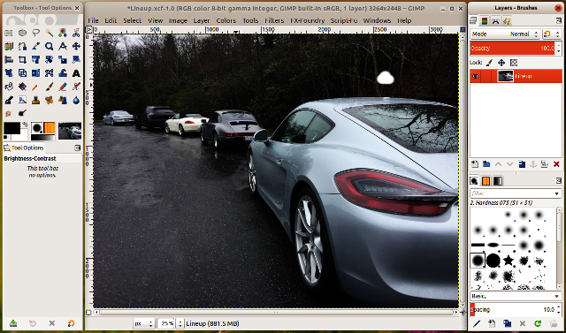
Figure 1. Unprocessed Photo.

In Figure 2 I’ve initialized GIMP to begin the processing. Note that the right panel now shows two layers, a white background below and the photo above. Note also the second thumbnail on the right in the top layer. This is a mask, on which I can draw black areas to hide portions of the photo. I could instead erase these areas on the photo, but such changes would be permanent. If I hide too much using a mask, it’s easy just to erase the excess marking. I’ve also added an alpha channel to this layer, which means that any areas I mask are transparent rather than being white. This will allow me later to use more than one layer at a time to combine the effects.

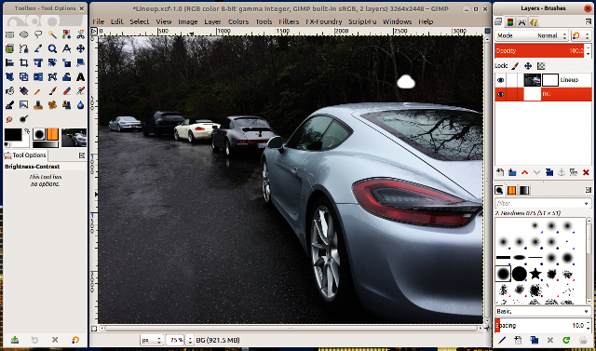
Figure 2. Photo Processing Initialized.

Figure 3 shows the effect of masking. Since the graphic will be used for a car show, I’ve removed everything but the cars and added some vignetting to soften the sharp edges on the right. I’ve also duplicated the layer several times, so I can try different processing on each one. Masking is done by hand and is quite tedious, almost impossibly so with a mouse, but far more tolerable with a graphics tablet. I use one by Wacom, which is small (about six by eight inches) and available for $70. Before duplicating the photo layer, be sure you have completed the masking, as you don’t want to repeat this time-consuming process.

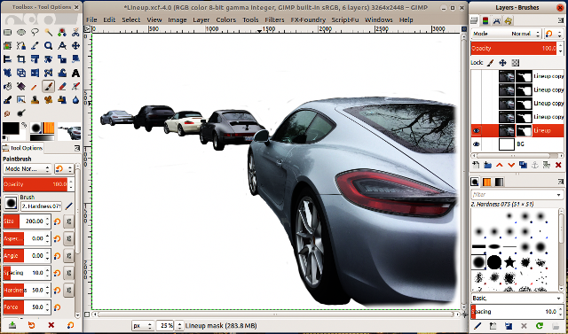
Figure 3. Masking Complete.

I used effects from the Grey’s Magic for Image Computing (G’MIC) add-on for GIMP, http://gmic.eu/gimp.shtml; other high-end graphic processors have similar utilities. Figures 4 through 7 show the effects of some of its filters.

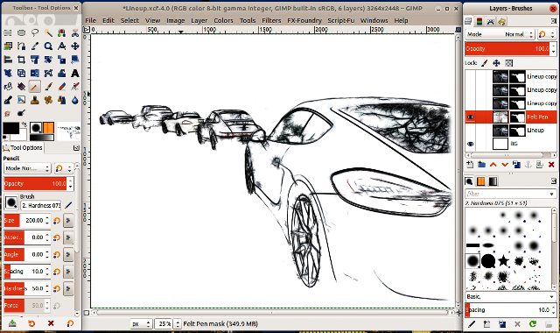
Figure 4. G’MIC Felt Pen Filter.

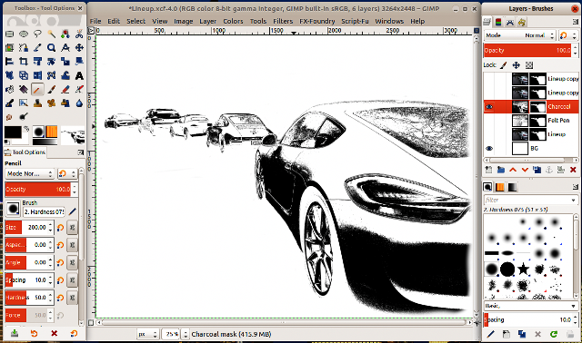
Figure 5. G’MIC Charcoal Filter.

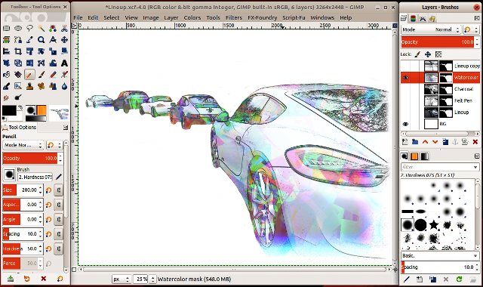
Figure 6. G’MIC Watercolor Filter.

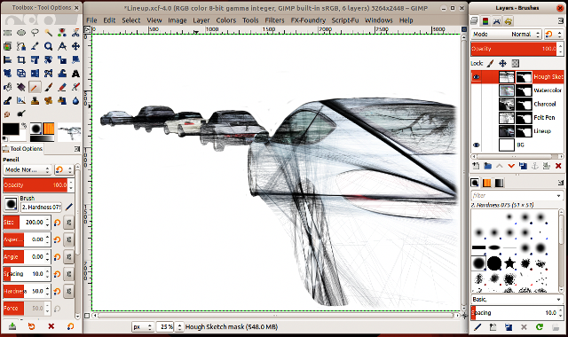
Figure 7. G’MIC Hough Sketch Filter.

Note the layer titled “Lineup,” which is the image of Figure 3, the photo after applying the mask but without an effect, filter applied. The filters are destructive, that is their effects can’t be undone. You will likely want to make some image processing adjustments after seeing the completed poster. By retaining the original image with masking, you can do this without having to repeat the tedious and time-consuming process of making another mask.

Often you will want to use the processed image as a background, meaning you’ll have to fade it to avoid obscuring the material that overwrites it. In Figure 8 the opacity of the layer has been reduced to 60 percent, and while this would keep any foreground text legible, the details of the image are now hard to discern.

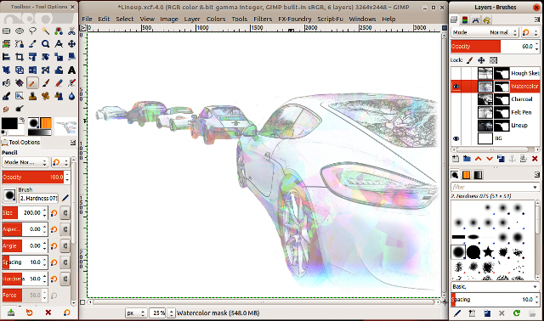
Figure 8. G’MIC Watercolor Filter with Reduced Opacity.

A solution is to combine the watercolor layer with the felt pen one by making both layers visible as shown in Figure 8.

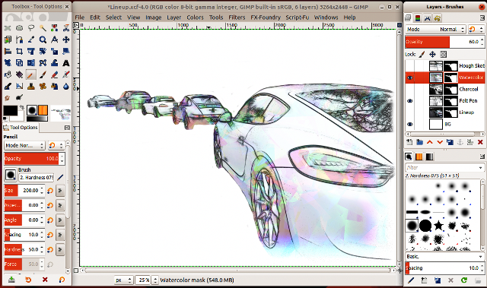
Figure 9. G’MIC Watercolor Filter with Reduced Opacity Combined with Felt Pen.

This preserves the cars’ outlines while keeping most areas of the image muted. Of course, after seeing the complete poster you’ll likely make some final adjustments. Posters are only one place where you can use graphics. After completing this project, I used a variant of the result as a background on a Website.

I’ve used GIMP here to illustrate what’s involved, but it’s similar to any high-end image processing program. As you probably have gathered, the procedures are involved, and you should be familiar with image processing before beginning something similar. Don’t make a project involving multiple layers and detailed masking your first graphic project.

